P234.2

#include<iostream>

using namespace std;

class student

{

public:

char name[20];

unsigned int id;

double score;

void input();

void output();

};

void student::input()

{

cout << "name?";

cin >> name;

cout << "id?";

cin >> id;

cout << "score?";

cin >> score;

}

void student::output()

{

cout << "name:" << name << "\tid:" << id << "\tscore:" << score << endl;

}

int main()

{

student s = student{ "\0",0,0 };

s.input();

s.output();

system("pause");

}

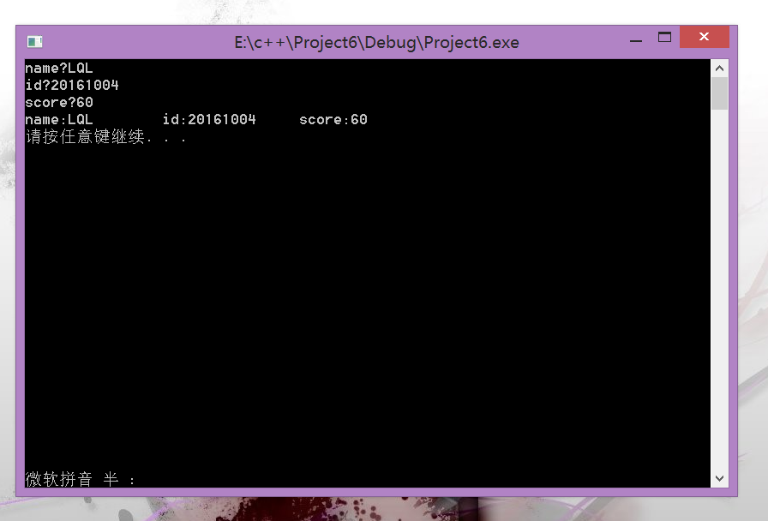

p242.1

#include<iostream>

#include<cstring>

using namespace std;

class Book

{

public:

double price;

int number;

char bookname[30] = "心理罪之教化场";

void display();

void borrow();

void restore();

};

void Book::display()

{

cout << "这本书的名字是：" << bookname << endl;

cout << "这本书的价格是：" << price << endl;

cout << "这本书的总共有：" << number << endl;

}

void Book::borrow()

{

int a;

cout << "请输入要借阅的书的名字：" << endl;

cin >> bookname;

cout << "请输入要借阅的数量：" << endl;

cin >> a;

if (number == 0)

{

cout << "该书已被借阅完毕，请见谅";

}

{

number -= a;

}

cout << "恭喜您，借书成功！" << "\n这本书还剩：" << number;

}

void Book::restore()

{

int b;

cout << "请输入要归还的书名：" << endl;

cin >> bookname;

cout << "请输入要归还的数量：" << endl;

cin >> b;

number += b;

if (number > 6)

{cout << "出现错误，请再来一次";

number -= b; }

else cout << "恭喜您，还书成功！" << "\n这本书目前剩余量：" << number << endl;

}

int main()

{

Book Book1;

int i;

Book1.price = 29.8;

Book1.number = 6;

cout << "想干啥？" << endl;

while (1)

{

cout << "查阅书籍请按1，借书请按2，还书请按3" << endl;

cin >> i;

switch (i)

{

case 1:Book1.display(); break;

case 2:Book1.borrow(); break;

case 3:Book1.restore();

}

}

return 0;

}

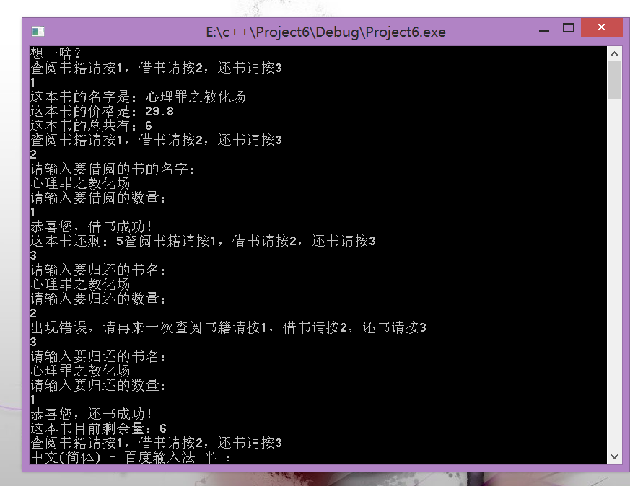

p242.4

#include<iostream>

using namespace std;

class student

{

public:

double score;

static double total;

static int count;

void scoretotalcount(double);

static double sum();

static double average();

};

double student::total=0;

int student::count=0;

void student::scoretotalcount(double s)

{

score=s;

total+=s;

}

double student::sum()

{

return total;

}

double student::average()

{

return total/(double)count;

}

int main()

{

student w;

int i;

int count;

double s;

cout<<"请输入班级学生总人数："<<endl;

cin>>count;

student::count=count;

for(i=1;i<=count;i++)

{cout<<"请输入第"<<i<<"个学生成绩";

cin>>s;

w.scoretotalcount(s);}

w.sum();

w.average();

cout<<"本班同学总成绩为："<<student::sum()<<endl;

cout<<"本班同学平均成绩为："<<student::average()<<endl;

System(“Pause”);

}

